Locations and Dislocations: Places and Spaces in Contemporary Women’s Writing
July 3-5, 2019
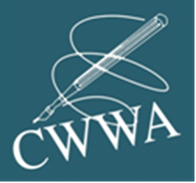
Postgraduate Travel Bursary - Application Form
Applications are invited for two Postgraduate Travel Bursaries of up to £200 to facilitate the participation of postgraduate students in the Locations and Dislocations: Places and Spaces in Contemporary Women’s Writing Conference. Applicants must be currently registered for a postgraduate degree (MA/MRes/PhD or other).

NB: The Travel Bursary is designed to cover travel and / or accommodation costs only. Expenses will be reimbursed following submission of appropriate receipts.

Please complete the proforma below and return to locationsdislocationsCWWA@gmail.com by Monday, June 3, 2019
Note that successful recipients will be required to write a brief blog about the conference for the CWWA website.

Name:
Email:
Institution:
Registration status (full or part time?):
Director of Studies / Programme Leader / Thesis Supervisor:
Email:
Title of proposed paper:
Abstract:

Supporting statement (up to 300 words): please outline how this award will help to advance your development as a researcher in the field of contemporary women’s writing

